RESUME
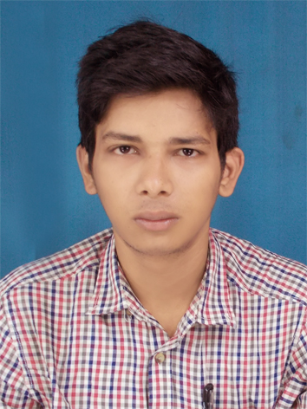

BISWAJIT GHOSH
SONARPUR SOUTH GHOSH PARA
, KOLKATA-700150
CONTACT NO.:8697096798

OBJECTIVE
Learn…innovate…apply…succeed…repeat….
The objective of my life is to serve humanity whatever ways I can through my selfless service in whatever organization I am working for.

EDUCATION

Examination | ▬Board/council | Subject | DURATION/YEAR OF PASSING
MBA | VIDYASAGAR UNIVERSITY | MARKETING MANAGEMENT & HUMAN RESOURCE MANAGEMENT | 2016
B.A. | SHRIDHAR UNIVERSITY | ENGLISH(H) | 2010-2013
H.S. | WBCHSE | SCIENCE | 2009
MADHYAMIK | WBBSE | ALL | 2007

COMPUTER SKILL

BASIC COMPUTING KNOWLEDGE.

HOBBIES
- Travelling .
- Driving.

EXPERIENCE
- 7 MONTH EXPERINCE IN IDEA POSTPAID DST.
- 1 YEAR 6 MONTH EXPERINCE IN FUTURA SURGICARE PVT.LTD AS A SALES OFFICER.
- 5 MONTH EXPERINCE IN LOTUS SURGICALS PVT. LTD.
- From 7th June, 16 I AM IN MCO HOSPITAL AIDS PVT.LTD AS A MARKETING EXECUTIVE.
WHO AM I

I am a person looking for challenges, innovation and a desire to breakaway from the regular through skilled leadership. Proactive and responsible I seek to shape my life and I usually carry my environment with me. In all my work I seek to keep the end in mind and come out winning and successful with desired results.
I do hereby declare that the above information is true to the best of my knowledge and belief.

Date : 22/04/2016 BISWAJIT GHOSH

